**Resource for SLOs and CLOs**

*Text in red font is an example. I used a fictitious major called “SACSCOC Reaffirmation” to write SLOs and CLOs. You can duplicate the CLO section for each course in the major/minor to*

**Student Learning Outcomes (SLOs) SACSCOC Reaffirmation**

* SLOs identify the skills and competencies students should achieve by program completion.
* Each major/standalone minor should have no less than three but no more than five SLOs.
* SLOs should be clear and measurable. They should use action words.

|  |  |
| --- | --- |
| SLO 1 | Students will be able to write a SACSCOC Reaffirmation self-study. |
| SLO 2 | Students will be able to create a plan to guide the institution through its SACSCOC Reaffirmation. |
| SLO 3 | Students will be able to train institutional stakeholders on key aspects of the Reaffirmation process and their roles in it. |
| SLO 4 | Students will be able to synthesize complex topics for diverse audiences. |
| SLO 5 | Students will be able to... |

**Course Learning Outcomes (CLOs)**

* Courses should have learning outcomes to convey their purpose within a major/minor. CLOs represent the skills and competencies students should demonstrate by the end of the course.
* CLOs should link to at least one major/minor SLO.
* Each course should have two to three CLOs per course. More is acceptable.

***CLOs for Course 1:* ACRD 201 SACSCOC Principles of Accreditation**

|  |  |
| --- | --- |
| **CLO 1** | Students will be able to write accreditation narratives to demonstrate compliance with the Principles of Accreditation. |
| **CLO 2** | Students will be able to conduct an audit of the Principles of Accreditation to identify areas in which their institution is not in compliance. |
| **CLO 3** | Students will be able to partner with institutional stakeholders to write accreditation narratives. |

**Course Learning Outcome and Student Learning Outcome Matrix**

***Relationship Between SLOs and CLOs***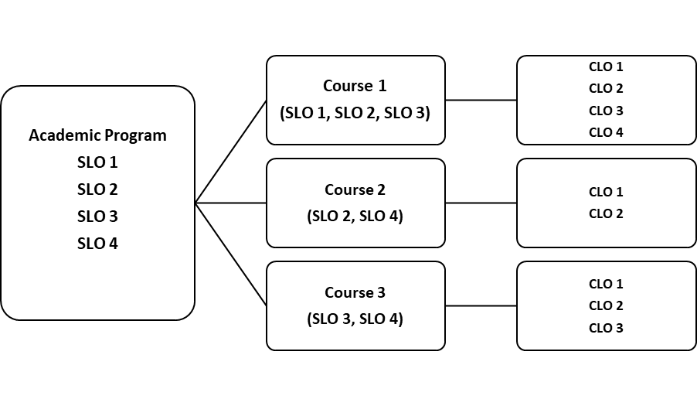  
***Course 1 Matrix: Integrating the SLOs and CLOs***

Mark an X where a CLO helps achieve an SLO. If a CLO does not align with an SLO, you should consider whether the CLO applies to the overall major/minor.

|  |  |  |  |  |
| --- | --- | --- | --- | --- |
|  | **SLO 1** | **SLO 2** | **SLO 3** | **SLO 4** |
| **CLO 1** | X |  |  |  |
| **CLO 2** |  | X |  |  |
| **CLO 3** |  |  | X | X |

**Complete the CLOs and CLO matrix for each course in the major/minor.**

**Curriculum Map**

Curriculum maps help organize academic programs by demonstrating which courses introduce and reinforce SLOs, and which courses indicate mastery and where assessment occurs. The matrix below can be used to organize your academic assessments. All the courses in the major/minor should be listed in the curriculum map.

In the matrix, you should indicate where a course Introduces (I), Reinforces (R), or Masters (M) skills and abilities outlined in the SLOS, and whether that course is an Assessment (A) course.

|  |  |  |  |  |
| --- | --- | --- | --- | --- |
|  | **Student Learning Outcomes** | | | |
| **Example courses:** | SLO 1 | SLO 2 | SLO 3 | SLO 4 |
| Course XX1 | I | I, A |  | I |
| Course XX2 | R | R | I |  |
| Course XX3 | R | M, A | R |  |
| Course XX5 | M, A |  | M, A | R |
| ETC... |  |  |  | A |
|  |  |  |  |  |
|  |  |  |  |  |